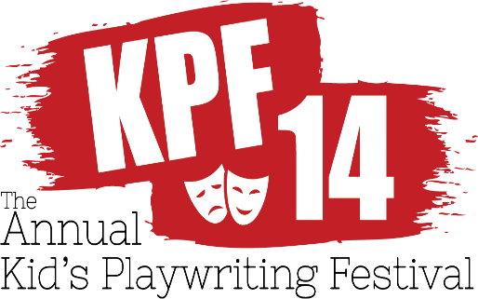
ENTRY FORM:
Print/Fill all information, sign, and date entry form. Parent or guardian must also sign form. Make sure that name, grade, address, phone number and title are on cover page only of your play. Please print your entry info clearly below. Please include page #s on your play(s). Attach completed and signed entry form to play with paper clip, and:

Mail to:
Twin Beach Players Preferably Email to:
Kids’ Playwriting Festival 14 OR kpf@twinbeachplayers.org (In a WORD & PDF Format)
P. O. Box 600 (Subject: KPF14 and Name of participant)
Chesapeake Beach, MD 20732
Entries must be postmarked/e-mailed by APRIL 15, 2019
Name______________________________________________Age:_______ Current Grade________
Title of Play____________________________________________________________________________
Street Address_______________________________________City, State, Zip ______________________
Phone _________________________________
Email_______________________________________________
School__________________________________
Homeroom Teacher’s Name__________________________
School Address ________________________________________________________________
This play is my work only. In entering it I agree to abide by all the rules of The Twin Beach Players Kids’ Playwriting Festival. If my play wins a prize, I give my permission for it to be performed and published by The Festival; providing my name is listed as author and with proceeds, if any, to go toward the Twin Beach Players Kids’ Playwriting Festival. I understand that once my play is produced on stage it becomes the property of Twin Beach Players.
Signature of Playwright__________________________________________Date___________________
Signature of Parent or Guardian __________________________________Date___________________

www.TwinBeachPlayers.org

