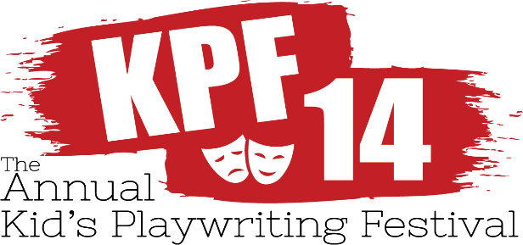

WHAT IS IT?
Every year, the Twin Beach Players host a playwriting competition, open to all school age children in the state of Maryland.
HOW DO I ENTER?
Any school age child may send their original play entry to:
TBP P.O. Box 600 Chesapeake Beach, MD, 20732 or
Email at kpf@twinbeachplayers.org
*ALL Entries, prior to submission, MUST be checked for proper spelling, grammar and punctuation
*ALL Entries MUST BE postmarked or emailed by 4/15/2019
THEN WHAT?
Winners are announced no later than May 30, 2019. Then, auditions are held for the top 6 winning plays.
Performances of the winning plays will be weekends
August 2-August 11 at the North Beach Boys and Girls Club. The 6 winning playwrights receive $100.00!!!!
All that enter receive a congratulatory commissioner’s certificate and coin at our VIP/Award night.
*Photos of past Kids’ Playwriting Festivals are on www.facebook.com/twinbeachplayers
www.TwinBeachPlayers.org

