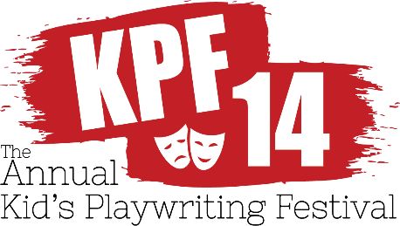
RULES:

- A completed and signed entry form must accompany each play.
- Name, grade, address, phone number, and title must also be on outside title page only. Pages of play should be numbered and include name of play only. Be sure to number pages and secure script in a folder. Please keep a copy of your play.
- Type script if possible. Plays handwritten or printed in ink will be accepted if easily readable. No pencils, please! Make sure proper spelling and grammar is used. Avoid too many scene changes to help your work stay in the proper suggested lengths of a play.
- Play must be the original work of ONE student submitting it. No collaborations. No adaptations. Adults may give advice on general terms about dramatic form, but all action, characters, and dialogue must be solely the work of one student.
- Festival is limited to non-musical plays (but scripts may call for brief music or song as part of action.) Otherwise plays may be of any kind (comedy, drama, science fiction, mystery, fantasy, etc.) on any subject, and in any number of scenes.
- Approximate playing times are suggested as guidelines for each division. The judges reserve the right to award prizes to outstanding plays that do not fall within these guidelines, but lengthy plays cannot be produced.

SUGGESTED LENGTH OF PLAYS:
Elementary School: 3-15 minutes
Middle School: 7-20 minutes
High School: 10-25 minutes
- Entries must be postmarked by APRIL 15, 2019.
- Festival is open to all Maryland State students, public, private, and home-schooled.
- We regret we cannot acknowledge receipt of your play, but winners will be notified no later than MAY 30, 2019.
- Each play will be read by a panel of at least three judges.
- Prizes will be awarded based on imagination and human values, as well as playwriting skill. The age and grade of the playwright will be taken into consideration by the judges.
- All winners will be awarded a $100.00. Several will be selected for production by Twin Beach Players weekends August 2-August 11, 2019 (with tech week beginning July 27th with LOAD IN)

www.TwinBeachPlayers.org

